---Depressing background starts----

* As of today, it is no surprise to anyone that this Coronavirus (Covid-19) pandemic is taking its toll in on our daily life both directly, and indirectly.
* The disease which was firstly identified in Wuhan, China (2019), has spread out its roots all over the world by now.
* With a mind-boggling current stat:

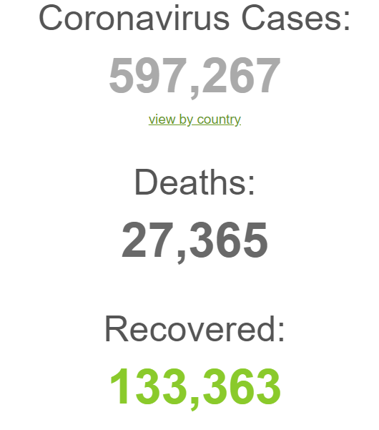

And it is increasing as the days go by…

Source: <https://www.worldometers.info/coronavirus/>

* At this time of need, one needs to learn not to panic over everything, and gather reliable and useful information as possible.

---Depressing background ends----

---Non depressing background----

* And for this very purpose, we are focusing on creating a system that can feed in reliable and useful information, which is mostly easily accessible to all.
* And what a better way to do that than creating a website?
* The website that we are going to build is mostly going to revolve around showcasing various information (from reliable sources), but all into one place.
* The proposed name of the website is Visualizer-19, which will consist various sections such as:
  + **Home/News Section:**

For providing various worldwide as well as local (Nepal) news and information related with the virus.

* + **Map Section:**
    - The essence of our system,
    - This section consists our country’s map, as well as its subdivisions, where the user can interact with the map and trace out the information such as total cases (recovered, deaths, ongoing), and certified health institutes and personnel of the respective area.

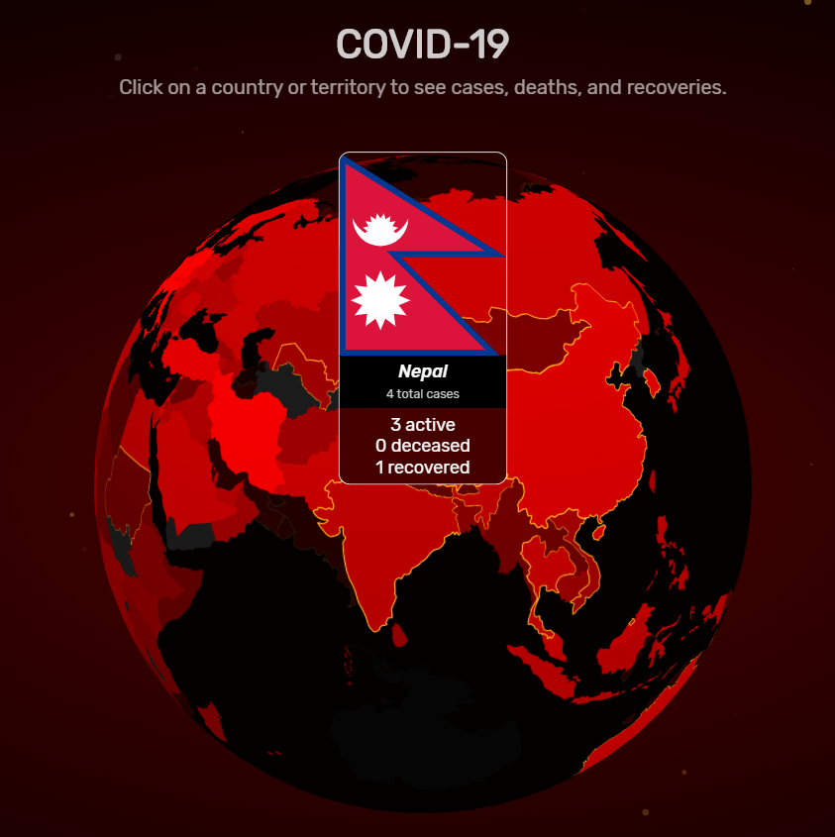

Source: [https://www.covidvisualizer.com](https://www.covidvisualizer.com/?fbclid=IwAR1Qe-ync_M9rEkNqdgys3I9iTGIFF5Wgr9B8rzASSKF1nqaGakYPcnmCy4)

* + **Life in Quarantine Section:**

To showcase various stuffs you can do in your stay at home.

* + **Test your knowledge Section:**

To test what you know, and what you should know about the virus.

* + **Login Section(Admin only):**

To manage all the stuffs in, and around the website.

---End of non depressing background----

---Finally (Somewhat of a plain background and all… )---

* Our team will give our best to bring this proposed system to life.
* Thank you for your time, and stay safe!

